**Sample Output/Demonstration of Results**

**(NOTE:** As per requirement 5 of output, all normal UnixLs has been printed one file per line)

* **Base Implementation:**
  + **UnixLS:**Text

    Description automatically generated
  + **LS:**
* **Different Directory A:**
  + **UnixLS:**
  + **LS:**
* **Different Directory B:**
  + Text

    Description automatically generated**UnixLS:**
  + **LS:**
* **-l argument:**
  + **UnixLS:**
  + 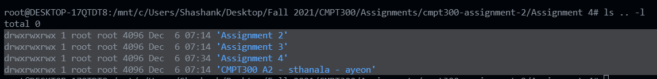**LS:**
* **-R argument:**
  + Text

    Description automatically generated**UnixLS:**
  + Text

    Description automatically generated**LS:**
* **-i argument:**
  + Text

    Description automatically generated**UnixLS:**
  + **LS:**
* **-li arguments:**
  + 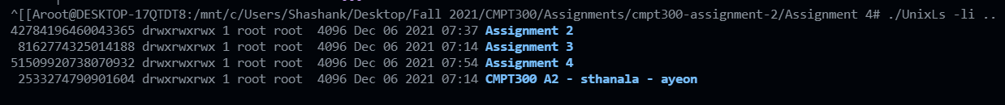**UnixLS:**
  + 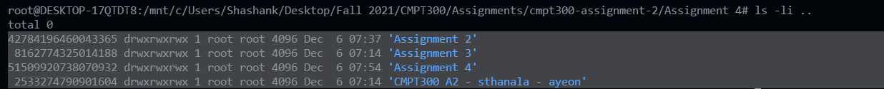**LS:**
* **-lRi arguments:**
  + Text

    Description automatically generated**UnixLS:**
  + Text

    Description automatically generated with low confidence**LS:**
* **Symbolic links:**
  + Text

    Description automatically generated**UnixLS:**
  + **LS:**

**Note:** Some terminals are highlighted because I am presently on WSL and sometimes the base ls shows directories in an unreadable format like:

Which is why I highlighted them just by selecting them.